Experiment 3

**Problem Statement:**

a) Write a shell program to find Fibonacci series.

b) Write a shell program to find largest of three numbers.

c) Write a shell program to find average of N numbers

code:-

A)

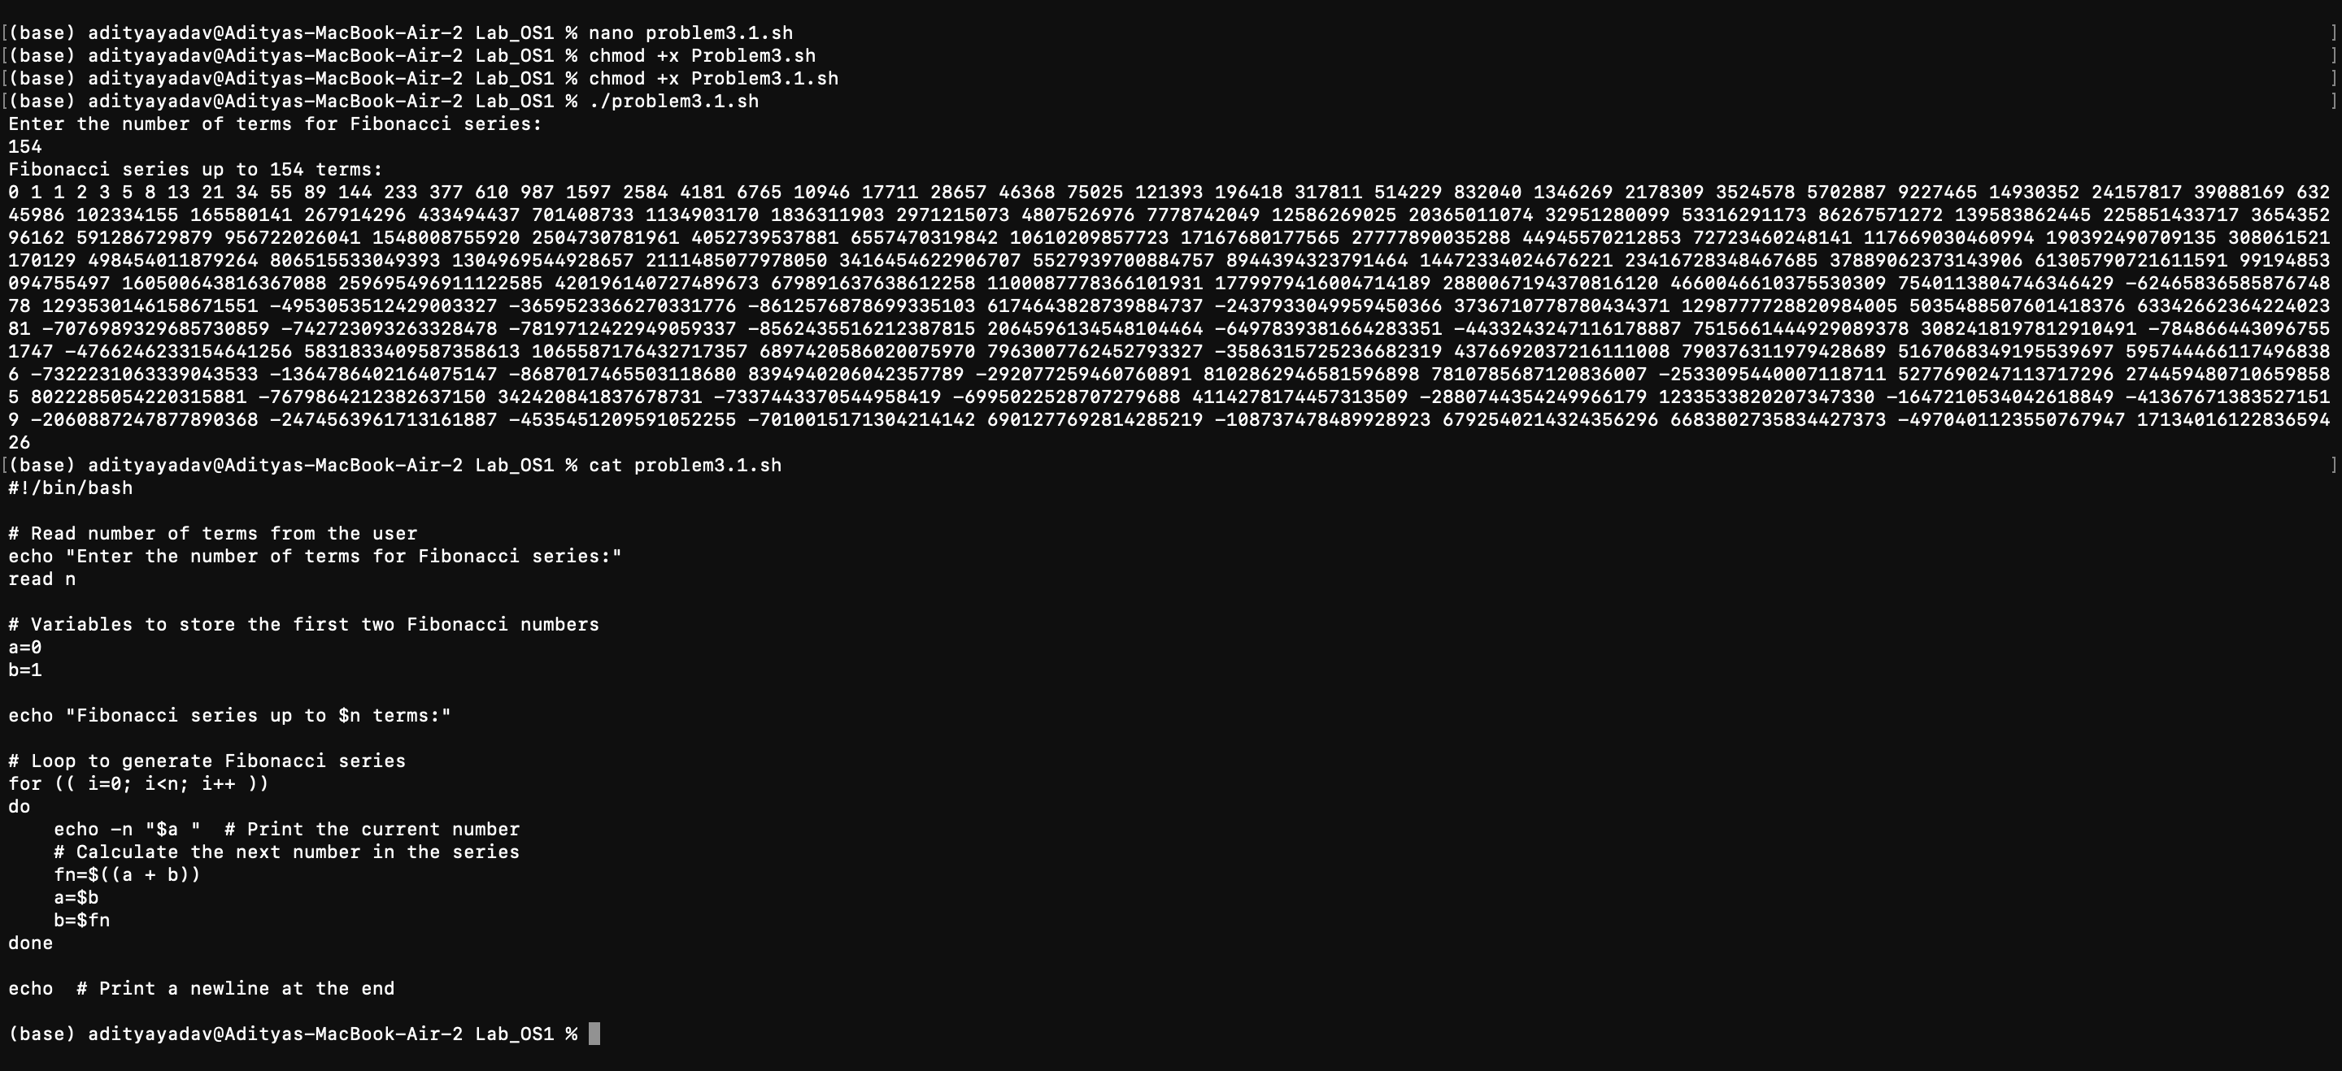

B)

